Broken Links are defined as links on your web page that do not work properly. If a user were to click on a broken link on your page, they would be redirected to an error page. To prevent problems like this from occurring, you can check the Link Checker on your Cascade Homepage to fix your broken links as soon as they happen and to prevent a bad user experience.

1. Log into [Cascade Server](https://csueastbay.cascadecms.com/login.act) and scroll down until you see a widget that says Link Checker.

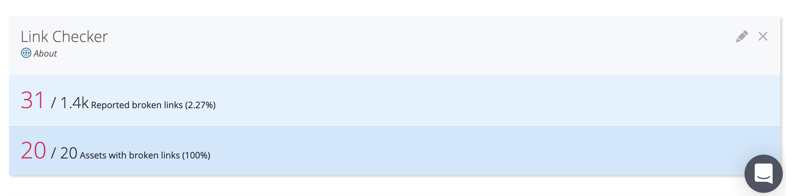

2. If the Name of your Site is not the one that is displayed under the words Link Checker, you can change this by clicking on the pencil icon in the top right corner and searching for your site and then clicking Save Settings.

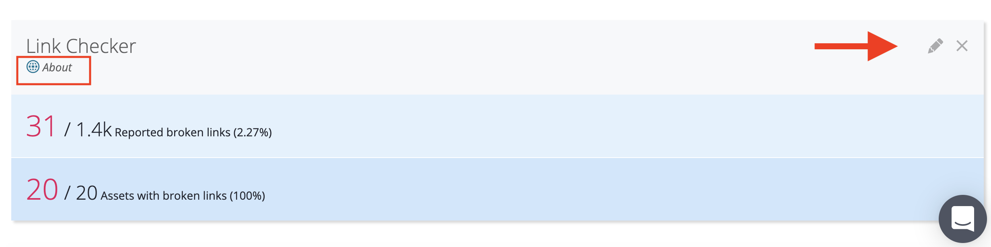

3. Click anywhere on the Link Checker widget and it will navigate you to the full Report of the Broken Links. At the top you will first see a general summary of how many total broken links your page contains.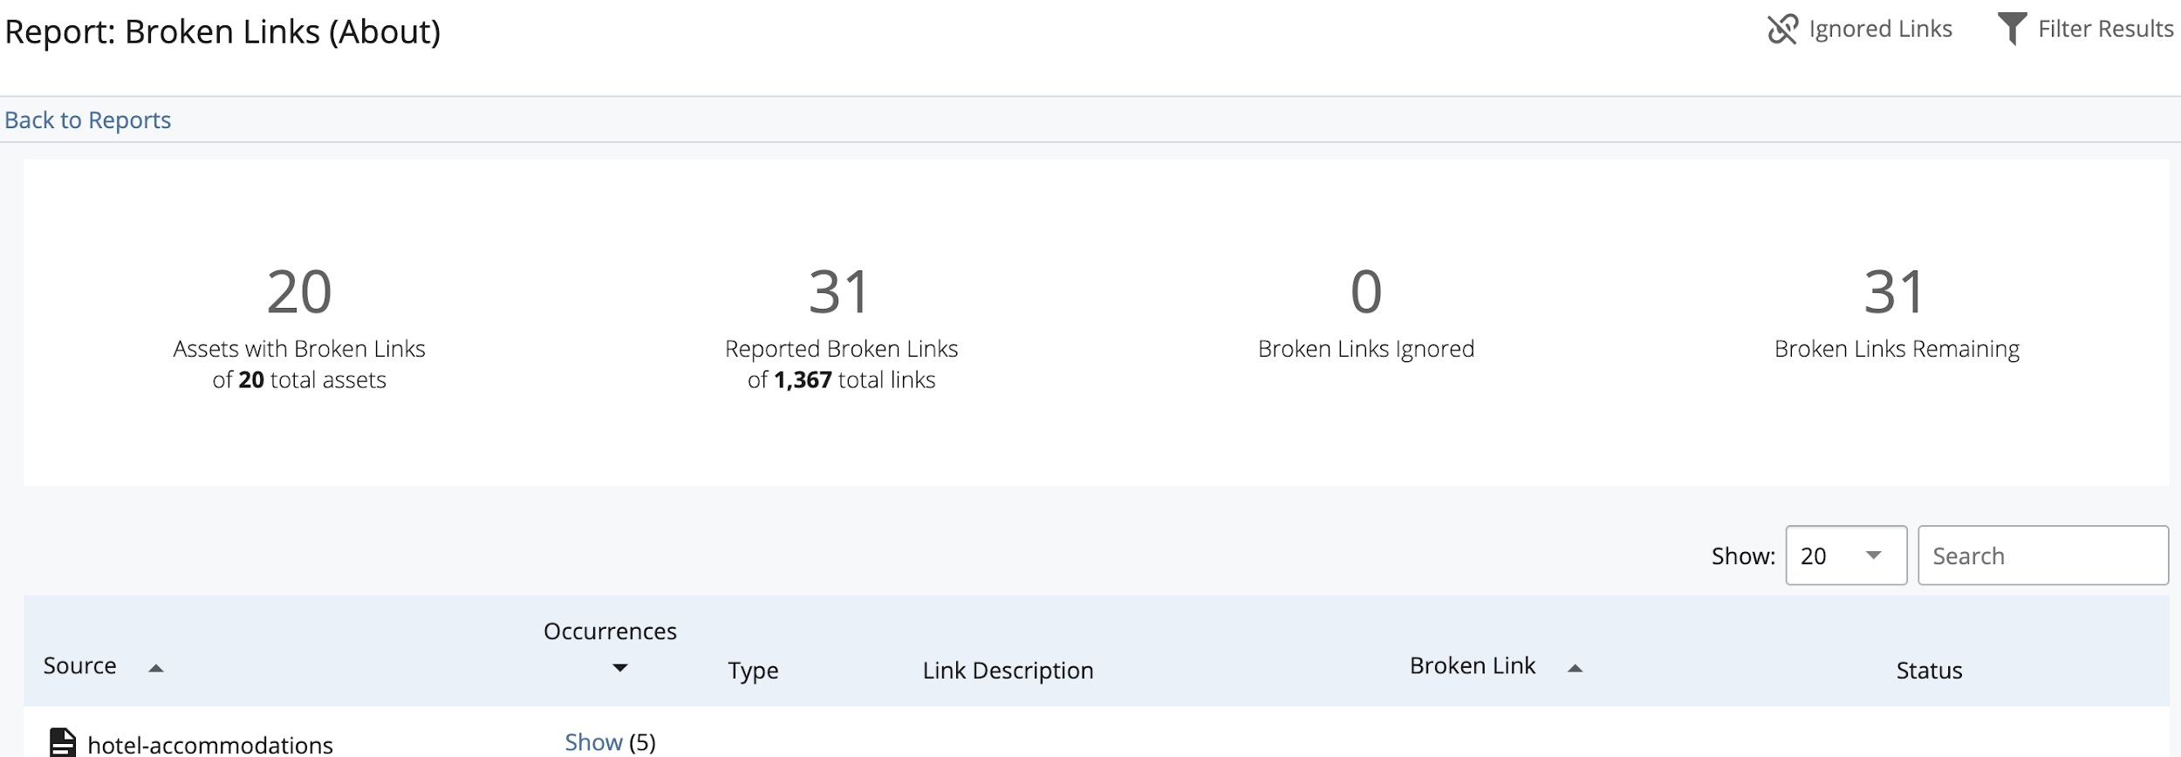

3a. First under the Source column, we see the name of each page within your site that contains each broken link. This helps you narrow down your search into sections to help fix the broken link.

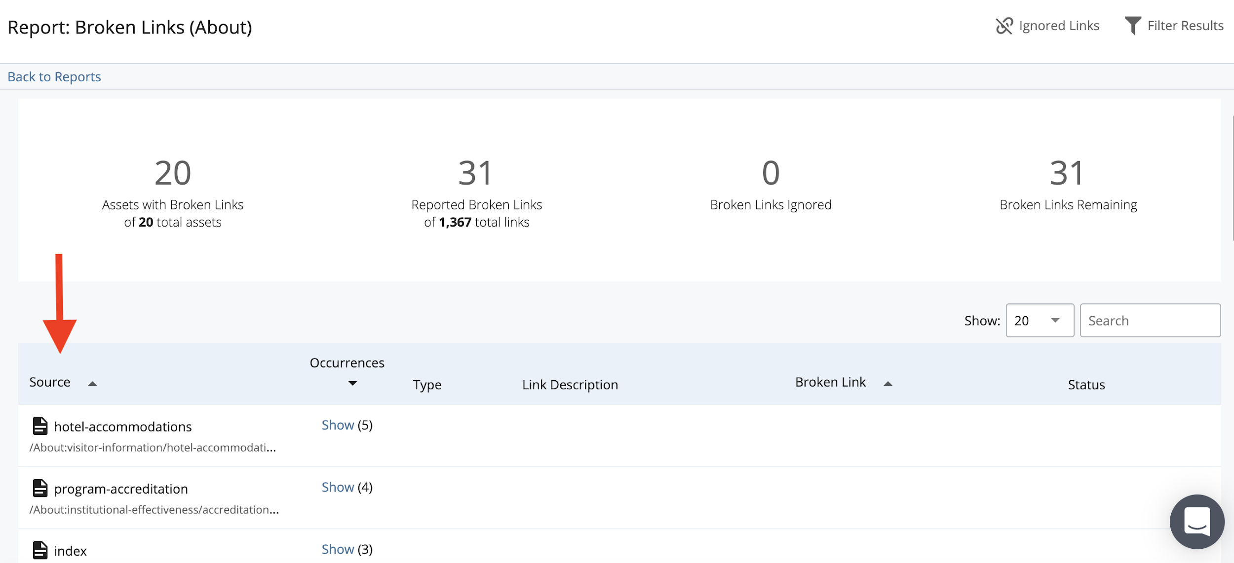

3b. In the next column above, we see Occurrences. If there are **multiple** broken links within that one page, you can click "Show" to display the subsection containing that section’s broken links and then "Hide" to hide the subsection away. If there is only **one** broken link within the page, then it will state 1 for one broken link. 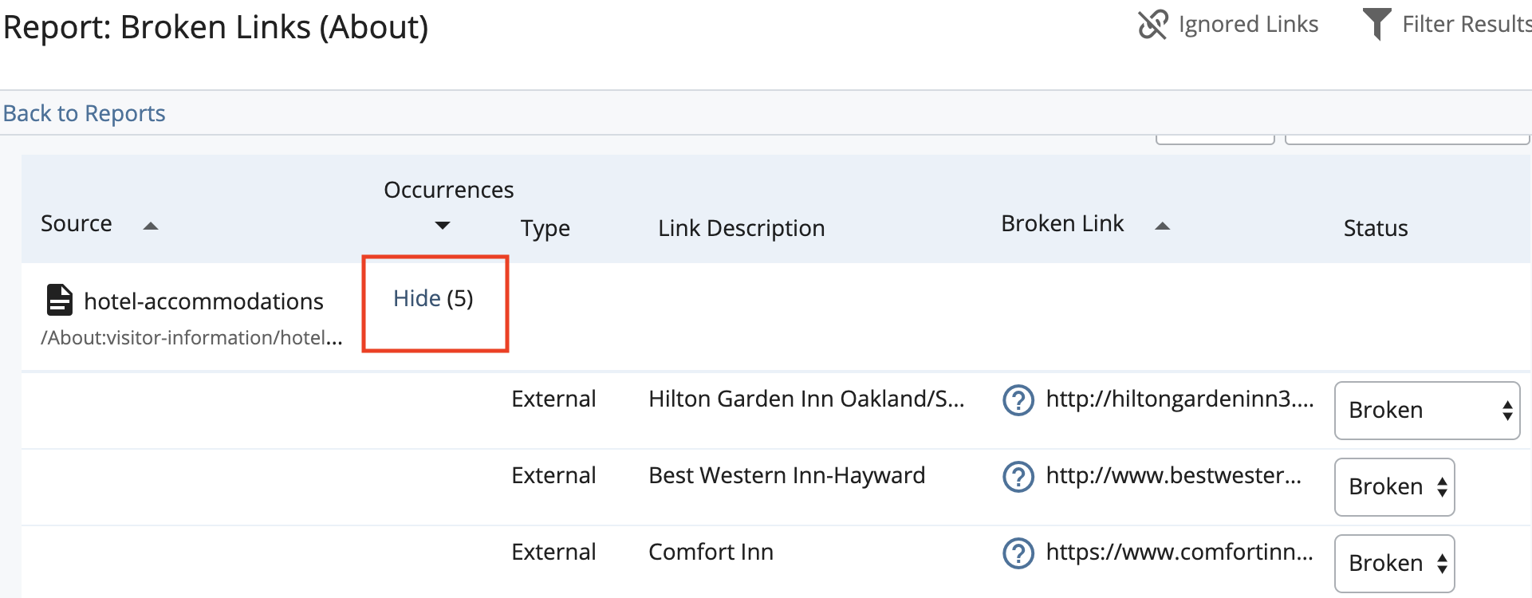

3c. The next column is theType. Here, you will either see External or Internal. If you see "External", that means the broken link is a link that is broken outside of your page and/or site but your page is still linked to it. If you see "Internal", that means that the broken link is linking somewhere within your own site or system. 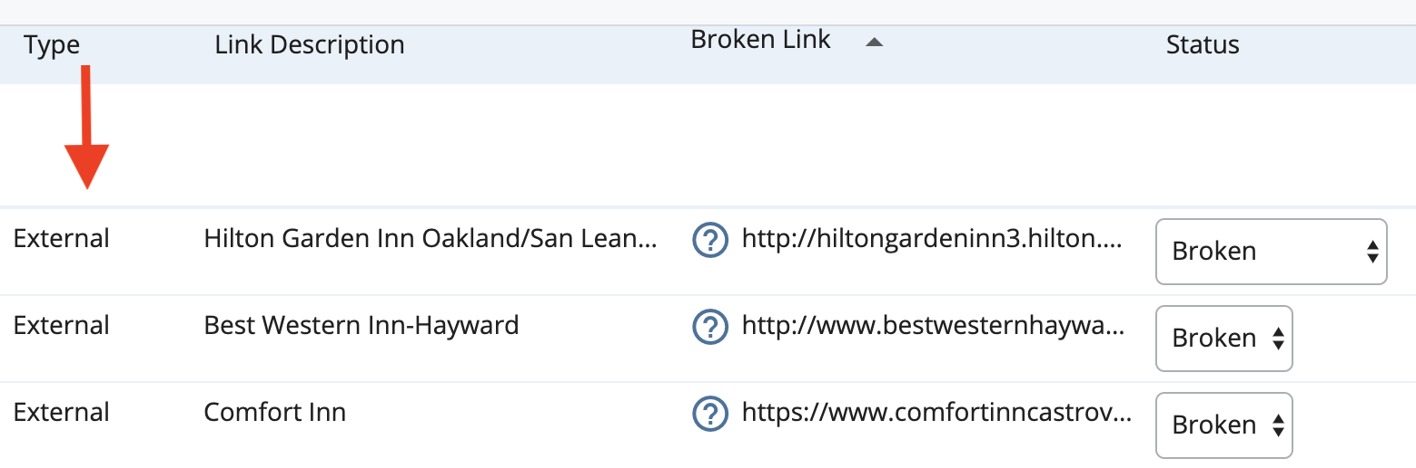

3d. The next column stated Link Description tells you what the exact issue is with the broken link. This way you can narrow your search down even further to what type of link you are trying to fix.

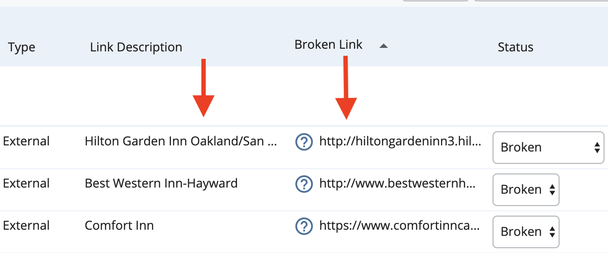

3e. The last column that you need to look at is theBroken Linkcolumn. Here you can find the exact URL and path to get to where your broken link is. This can also help you check whether your broken link is External or Internal.

4. The Link Checker is very useful when trying to fix broken links on your site. This widget helps you analyze where exactly the broken link issue is and where you need to go within your site to fix it.